7-11-25
Week – 5

1.
select e.empno ,e.ename, d.Dname , d.Dloc
from employee e , dept d
where e.Dept_no=d.Dept_no;

o/p:
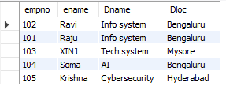

2.
Select e.ename ,e.empno
from employee e
where empno not in (
select empno from assignedto);
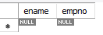

3.
select p.Pno ,p.Pname , count(a.empno) as head_count
from project p , assignedto a
where p.Pno =a.Pno
group by p.Pno , p.Pname;
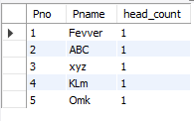

4.
select d.Dept_no ,d.Dname , avg(e.sal) as avg_salary , max(e.sal) as max_salary
from dept d , employee e
where e.Dept_no=d.Dept_no
group by d.Dept_no ,d.Dname;
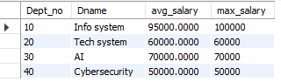

5.
select e.ename , sum(i.incentive_amt) as total_incentives
from employee e , incentives_ i
where e.empno = i.empno
group by e.ename;
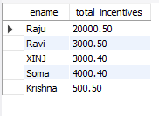

6.
select e.empno , e.ename , p.Pname
from employee e , assignedto a , project p
where e.empno = a.empno and p.Pno = a.Pno and p.Pname ='Alpha projects';
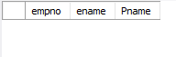

7.
SELECT d.Dept_no , d.Dname
from dept d
where d.Dept_no not in ( select Dept_no from employee);
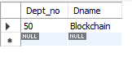

8.
Select e.mgr_no as mgr_id , m.ename as managername , count(*) as repot_count
from employee e , employee m
where e.mgr_no = e.empno
group by e.mgr_no,m.ename;
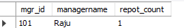

9.
select e.empno , e.ename
from assignedto a , employee e where e.empno= a.empno
group by empno
having count(pno)>1;

